## **Fork this repository**

* git clone "the copied url"
* git remote add upstream < collab Upstream repository address >
* First, lets make sure we have the latest version of the upstream repository by running (do this before each time you create a new branch):
* git fetch upstream
* Create your new branch by running:

git checkout -b <your-new-branch-name> upstream/master

### **Make your changes**

* git status
* git add
* git commit -m "Your message"
* git push origin <your-new-branch-name>

Note: Replace <your-new-branch-name> with the name of your branch

* **Open a Pull Request**
* Head over to your repository on GitHub and click on the green "Compare and pull request" button.
* 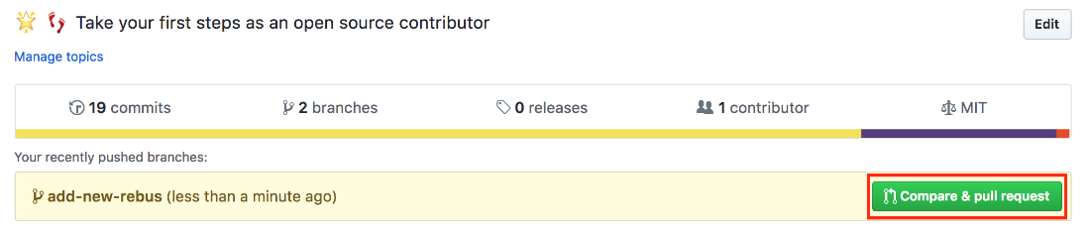
* Describe your changes and submit your pull request
* 